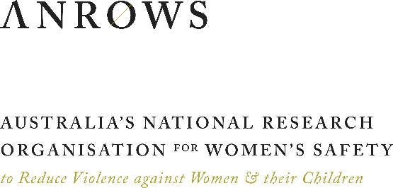
MEDIA RELEASE
WEDNESDAY 25 MARCH 2020

VICTIMS/SURVIVORS OF SEXUAL ASSAULT SUPPORT COMMUNITY REINTEGRATION FOR OFFENDERS
Community safety is improved when sexual offenders are supported to reintegrate into communities.
Programs that provide this support to offenders should be resourced, according to research published today by Australia’s National Research Organisations for Women’s Safety (ANROWS).
The researchers, led by Associate Professor Kelly Richards at the Queensland University of Technology, investigated two community-based, non-therapeutic programs providing reintegration support in Australia.
They documented the characteristics of Circles of Support and Accountability in Adelaide and the Cultural Mentoring Program (CMP) in Townsville. The research aimed to contribute to our understanding of how community-based programs affect recidivism.
Very little research of this kind has been conducted in Australia.
Circles of Support and Accountability was shown to help participants build new identities as non-offenders, while holding members to account by providing them with a network of community-based volunteers. The CMP works with released Aboriginal and Torres Strait Islander offenders, building strong and positive non-offending cultural identities with a focus on connections with family, culture and Country.
Victims/survivors were consulted on the effectiveness of the reintegration programs. While views were diverse, victims/survivors said that these programs help increase their sense of safety as the perpetrator is being monitored by services who are able to report concerns.
“What this confirms is that we should be seriously considering further investment in programs that reintegrate sexual offenders,” said Professor Richards.
“By keeping the community safer, these programs are an important investment in the wellbeing of women who have experienced sexual violence. They also carry the added benefit of significant cost savings in the longer term. Both programs deserve to attract funding for their expansion, followed by a larger-scale evaluation.”
Victims/survivors advised a response to offenders that is pragmatic, not punitive.
“What victim/survivors told us is that the safety of women, their children and the community as a whole is more important than the punishment of offenders,” said ANROWS CEO Dr Heather Nancarrow.
“This research shows that programs need to prevent future sexual offending, providing women with a sense of physical and emotional safety. This includes effectively reintegrating perpetrators into the community.”
The victims/survivors called for strategies that:
- physically distance victims/survivors from offenders
- provide victims/survivors with information on the release of offenders
- offer pathways to affordable and accessible therapeutic interventions for both victims/survivors and perpetrators
- ensure monitoring of perpetrators and provide them with help addressing their offending-related needs.

These safety needs were found to align closely with the goals of the two programs that were studied.
This research forms part of ANROWS’s ongoing research stream investigating interventions with perpetrators of domestic, family and sexual violence.

For further information, contact Michele Robinson at ANROWS
on +61 0417 780 556 or email michele.robinson@anrows.org.au.

About ANROWS
Australia’s National Research Organisation for Women’s Safety Limited (ANROWS) is a not-for-profit independent national research organisation.
ANROWS is an initiative of Australia’s National Plan to Reduce Violence against Women and their Children 2010–2022. ANROWS was established by the Commonwealth and all state and territory governments of Australia to produce, disseminate and assist in applying evidence for policy and practice addressing violence against women and their children.
ANROWS is the only such research organisation in Australia.

