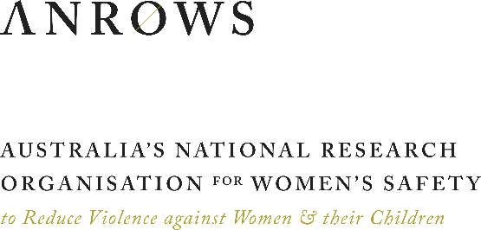
MEDIA RELEASE
Friday 10 May 2019

10th anniversary of Time for Action, the blueprint for the

National Plan to Reduce Violence against Women and their Children 2010-2022

Newly appointed Minister for the Prevention of Domestic Violence, the Hon Mark Speakman, will meet with the National Council to Reduce Violence against Women and their Children (2008-09) at NSW Parliament House today to mark 10 years since they presented Time for Action to then Prime Minister, Kevin Rudd.
Time for Action provided the blueprint for the subsequent Council of Australian Governments' National Plan to Reduce Violence against Women and their Children 2010-2022 (the National Plan).
The National Plan has enjoyed continued bi-partisan support through a series of three Action Plans that have been implemented under the National Plan, to date. The 10th anniversary of Time for Action coincides with the move into the fourth and final Action Plan of the current 12-year National Plan.
“This is an opportunity to reflect on how far we’ve come, and where we’re going in our efforts to achieve a significant and sustained reduction in rates of violence against women,” said Ms Libby Lloyd AM, Chair of the former National Council to Reduce Violence against Women and their Children. “It is also time to celebrate the passion and commitment of the sector working toward the National Plan goals.”
The Hon Mark Speakman will co-convene the event together with Australia’s National Research Organisation for Women’s Safety (ANROWS). ANROWS was established as an initiative under the National Plan to build the evidence base and support the transfer of evidence to policy and practice.
“It’s great to see the progress that’s been made so far under the National Plan, and we will continue to support ANROWS’s work to drive evidence-based reforms and solutions for some of the most vulnerable people in our community,” Mr Speakman said.
The National Plan is now in its final stages with both the government and the opposition promising significant investment in the Fourth and final Action Plan of the National Plan, if elected. Primary prevention is a key priority of the major parties.
Dr Heather Nancarrow CEO of ANROWS said: “Primary prevention is a critically important long-term strategy, and evidence-based early intervention and response to address harm, including homicide, is also critical.”
Ms Lloyd said she was pleased with the bipartisan support for the National Plan.
“The shocking rate of homicide and the continuing national crisis of violence against women highlights the need to keep the momentum going,” Ms Lloyd said.
“It is pleasing to see the wider community calling for the end of violence against women. “This much-needed groundswell of support is welcomed and signals hope for achieving our objectives.”

For further information, contact ANROWS on +61 0417 780 556 or email media@anrows.org.au.

