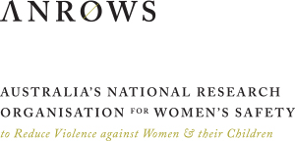
The forgotten victims
Prisoner experience of victimisation and engagement
with the criminal justice system:
Key findings and future directions
RESEARCH TO POLICY & PRACTICE
ISSUE 01 | AUGUST 2018

ANROWS Research to policy and practice papers are concise papers that summarise key findings of research on violence against women and their children, including research produced under ANROWS’s research program, and provide advice on the implications for policy and practice.

This is an edited summary of key findings from ANROWS research The forgotten victims: Prisoner experience of victimisation and engagement with the criminal justice system. Please consult the ANROWS website for more information on this project and the full project report: Day, A., Casey, S., Gerace, A., Oster, C., & O’Kane, D. (2018). The forgotten victims: Prisoner experience of victimisation and engagement with the criminal justice system (Research report, 01/2018). Sydney, NSW: ANROWS.

ANROWS acknowledgement
This material was produced with funding from the Australian Government and the Australian state and territory governments. Australia’s National Research Organisation for Women’s Safety (ANROWS) gratefully acknowledges the financial and other support it has received from these governments, without which this work would not have been possible. The findings and views reported in this paper are those of ANROWS and cannot be attributed to the Australian Government, or any Australian state or territory government.

ANROWS research contributes to the six National Outcomes of the National Plan to Reduce Violence against Women and their Children 2010-2022. This research addresses National Plan Outcome 4 – Services meet the needs of women and their children experiencing violence.

ANROWS would like to acknowledge the philanthropic support of Sparke Helmore Lawyers for this research, without which it would not have been possible.

It is also important to acknowledge the lives and experiences of the women and children affected by domestic violence and sexual assault, who are represented in this resource. It is important to recognise the individual stories of courage, hope and resilience that form the backdrop of this research.
Caution: Some people may find parts of this content confronting or distressing.
Recommended support services include: 1800 RESPECT – 1800 737 732, Lifeline – 13 11 14

Acknowledgement of Country
ANROWS acknowledges the traditional owners of the land across Australia on which we work and live. We pay our respects to Aboriginal and Torres Strait Islander elders past, present and future, and we value Aboriginal and Torres Strait Islander history, culture and knowledge.

Overview

Project aim
Many women in prison have experienced intimate partner violence (IPV). As this form of violence is often intergenerational and entrenched, women in prison are widely considered to be at particular risk of ongoing victimisation following release from prison. And yet, their support needs often go unrecognised, and it is likely that a range of barriers exist that prevent ex-prisoners from accessing services.

This summary of the The forgotten victims: Prisoner experience of victimisation and engagement with the criminal justice system research was prepared by ANROWS. It draws on the report from the research led by Professor Andrew Day in partnership with the Department for Correctional Services, South Australia. The research focused on women in prison concerned about their personal safety post-release. The aim of this research is to understand the factors that influence these women to seek help, and how this might inform service responses.

Methods
A literature review identified a range of different models of help-seeking, as well as how the specific needs of incarcerated women might create additional barriers to accessing services. A simple three stage model of help-seeking was identified as a useful way of integrating this work. This suggests that any individual who experiences IPV must:
- Recognise and define the situation as abusive and intolerable (Stage 1).
- Decide to disclose the abuse and seek help (Stage 2).
- Identify a source of support and where to seek help (Stage 3).

At the same time, the ability to seek help is influenced by a broad range of individual, interpersonal and socio-cultural factors including:
- the woman’s own history (e.g. childhood abuse);
- the personal networks in which she interacts, and the history of these networks (e.g. family relationships);
- connections between networks or systems (e.g. relationships between the abuser and the woman’s family);
- formal and informal social structures that influence the woman indirectly (e.g. housing, finances); and
- overarching institutional systems at the cultural or subcultural level (social/cultural norms and prejudices).

Figure 1 (overpage) provides a summary of the factors that influence help-seeking for women in prison at each stage of the model.

Data about help-seeking was collected from three different sources. These included interviews with women in prison, a survey completed by women in prison and interviews with key agencies and service providers. All of the data sources were used to:
- explore the perceptions and experiences of women in prison in accessing and utilising IPV and criminal justice-based support services both before and after incarceration;
- explore the perceptions of women in prison regarding their post-release needs for services; and
- examine the views and experiences of key service providers and stakeholders about providing services to women in prison.

Twenty-two women incarcerated in Adelaide Women’s Prison were interviewed. All of the interviewees identified as Australian, with nine identifying as Aboriginal, and one as Australian-European. The average age of participants was 33 years and most had completed some high school. Fifteen of the 22 reported that they had children, ranging in age from a newborn to 30 years of age. At the time of the interview, 15 of the women were waiting to be sentenced and seven had been convicted. For those who were sentenced, the reported terms of imprisonment ranged from 3 weeks to 4 years and 5 months. Participants reported that they had spent between 3 weeks and 20 years in prison, and were housed in different parts of the prison, including high security.

Twelve service providers from the same jurisdiction as the prisoner participants participated in the research. Invited service provider groups included representatives from correctional services, women’s safety services, the non-government sector, prisoner advocacy, health and victim support agencies.

Where possible, each interview was recorded and audio-transcribed for analysis.

Figure 1 Model of help-seeking and change for women in prison
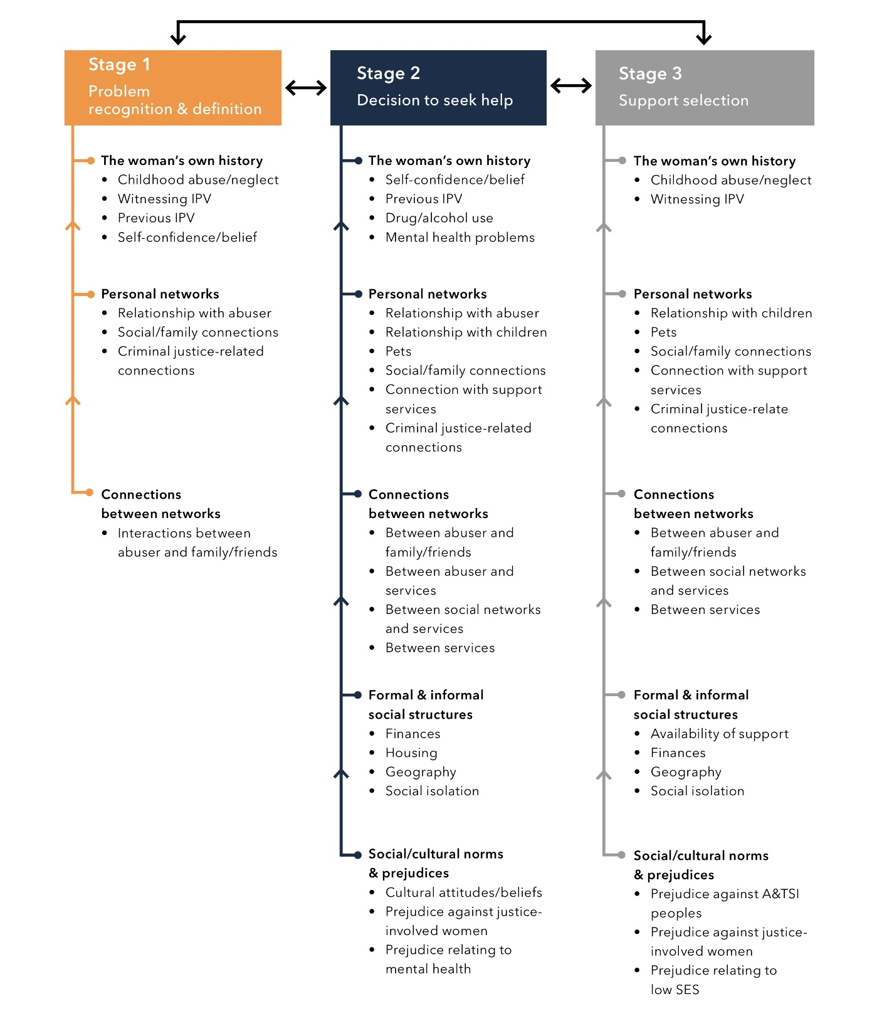

(Adapted from Day, Casey, Gerace, Oster, & O’Kane (2018).)

Key findings
The interview and survey results were analysed using the three stage model of help-seeking: (1) recognise and define the situation as abusive and intolerable; (2) decide to disclose the abuse and seek help; and (3) identify a source of support and where to seek help. A full analysis can be found in The forgotten victims: Prisoner experience of victimisation and engagement with the criminal justice system (Day et al., 2018) Research report.

Stage 1. Problem recognition and definition
For the women in this study, IPV was defined and recognised mainly in relation to individual history and the availability of personal support networks. Several of the women had significant personal histories of violence, including a history of childhood abuse and/or neglect; witnessing IPV as a child; or their own past experience of IPV. This affected their ability to recognise violence in two ways: for some, violence had become a normalised experience and this hindered their ability to identify it as a problem; for others, it helped them to recognise when violence had become an issue in their relationship. One of the main triggers that led women to identify violence as a problem was when it escalated to serious and life-threatening physical abuse. However, for some this was negated by the fear that seeking help would lead to an escalation in violence:
It got to the point where I needed an ambulance and that’s . . . I really thought I was going to die and that’s where I realised that things weren’t going to change. (Interview 8)

For many women, it was only with changes in their sense of self, frequently following intervention from counsellors, that they came to recognise IPV as an abnormal situation. At times, connection with the criminal justice system provided a new perspective on IPV. Access to prison programs and relationships with other women in prison offered an opportunity to reflect on their relationships. As one woman noted:
I know people who come to jail and they realise their relationship is bad. Jail is probably a service in itself. That sounds weird, but you get time to think in here and you get time to realise what was the good – the good, the bad and the ugly. (Interview 9)

Staff from correctional services further noted some of the complexities in assisting women in prison:
It’s a heightened responsibility when the abuser and the woman are both in our system together, which is not uncommon. (Service provider #5)

Stage 2. The decision to disclose and seek help
After recognising that there is a problem in their relationship, the decision to seek help was dependent on a number of interacting issues across all five factors that influence help-seeking. At the level of the individual, help-seeking required a level of self-confidence, and many acknowledged that they struggled with this:
I think for many women in here [prison], they don’t believe in themselves and they worry more about . . . the barriers and what can’t we do rather than what we can do to improve our lives. (Interview 1)

This could be compounded by other factors. Drug and alcohol use was considered a pervasive issue for incarcerated women when out of prison, who often used it as a means of escaping IPV.

I use drugs on the outside [of prison] and when you’re straight you have to deal with it and all the emotions and stuff . . . Yeah, that’s why on the outside I haven’t sought help. (Interview 5)

Family played an important role in decision-making. For several women, the negative effect of IPV on their children was the main reason to seek help. For example, one of the women took action:
Just because my son had seen it that’s when I thought it was beyond a joke, so I thought I needed to talk to somebody. (Interview 17).

For others, children played a role in the decision not to leave. This was either because they did not know where to go that could accommodate their children, the desire to preserve their children’s relationship with their father or fears that they would lose their children. While relationships with friends and family could, at times, facilitate help-seeking it could also lead to feelings of embarrassment and shame.

Cultural values relating to how marriage should function prevented other women from seeking help, with one woman describing being brought up in a family where you “don’t talk about what happened behind closed doors” (Interview 19). In contrast, many women did not make the decision to seek help themselves – it was family, friends or members of the community who intervened on their behalf when they identified that there was a problem.

Social isolation could restrict women’s options: “I had to quit my job; I couldn’t work anymore and I didn’t have my family so I had nowhere to go” (Interview 18). Many were cut off from their social networks or support services by the perpetrator of the violence. Geographic isolation also made it difficult for some to access services.

Some women chose not to seek help because they were financially dependent on the perpetrator or relied on the perpetrator for stable housing. This could be a particular problem in the period following women’s release from prison.

Women’s connection with, and knowledge of, support services was another important determinant of the decision about whether or not to seek support. Several women were not aware of the services that existed. Those who knew that services were available, feared not being believed. This related to the extent to which the IPV was visible: “sometimes it’s hard to get help out there unless you’re a lot busted up” (Interview 22). Fear of not being believed was particularly the case for women who had a connection with mental health services:
I’ve got schizophrenia he uses that against me a lot . . . the people I did talk to about it, they wouldn’t believe me because then when they would go speak to him about it he’d be like no, she’s just had another episode or – so that’s, it was always then put back onto me and my fault. (Interview 10)

Women also described the range of prejudices that prevented them from seeking help, which added to their fears that they would not be believed. These included discrimination based on identifying as an Aboriginal or Torres Strait Islander, having a mental illness or a criminal record.

One of the main barriers to receiving help was the need to go through complex procedures to access services. Some interviewees chose to return to the perpetrator after experiencing difficulties in accessing services or disliking the strict rules that were in place.

I would never ask them for a single thing again. I would sooner rather cop a beating every day of my life from my partner than go back to one of them. (Interview 7)

Two of the women were afraid that if they sought help, the services would then contact police or welfare services. This connection between services had resulted in both women having their children taken into out-of-home care in the past.
Service providers also acknowledged that women’s lack of trust was an impediment to their help-seeking:
Now, a lot of people in prison are – I wouldn’t say authority-averse, but their experiences with authority haven’t been great, so to reach out and to then have surveillance, perhaps, of your children through failure to protect, they’re all big obstacles. (Service provider #9)

A key focus for service providers was the relationships, or lack of relationships, that exist between different services, as well as uncertainty about the role that different agencies have to play in responding to IPV.

I think that that’s actually an inherent challenge for all correctional services . . . in terms of programs again there’s not been a great deal offered by the agency itself around the victim. Most of the service that gets delivered has been from external agencies coming in. Some of that is as a result of the growing relationship between us and the domestic violence sector. (Service provider #5)

Stage 3. Identifying a source of support
The women who participated in this research discussed a range of potential supports for IPV, both formal and informal. As with Stage 2, support selection was influenced by all five factors in the help-seeking model.

Women’s previous experiences of childhood abuse/neglect and witnessing IPV affected support selection, and in particular, decisions not to seek support from formal sources. They tended to prefer informal sources of support from family and friends and this assisted in their decision-making by providing advice about which formal services to connect with, or where not to go. However, the perpetrator’s interaction with family or friends could prevent women from seeking help from these sources.

I didn’t want to bring any of my friends or family involved because I was scared of what he would do. If he could do this to me, can you just imagine what he could do to others? (Interview 12)

Women’s relationships with formal support services affected their support selection. Having knowledge of what formal supports are available, and what these supports can offer, determined whether or not women would consider this type of support.

Just if they had more information on them, there is nothing here [in prison], there’s no pamphlets, or there’s…nothing to give out to people so that they…know where to go. (Interview 3)

In situations where women had sought formal support, the availability and response of these services influenced women’s future help-seeking.

Interviewee: No, I didn’t go to the police, because they didn’t help.
Interviewer: In what way?
Interviewee: In the way of I had about five or six reports made to the police and then they all disappeared. (Interview 16)

Fear of the police was a particular concern among the study participants. Often, women did not believe that accessing police support was an option:
There was no way in hell I was going to the cops, I was on parole. At the end of the day, I was the one with the criminal record, not him. (Interview 15)

Some women stated that going to prison was a way for them to escape IPV: “a lot of girls come to jail to get away from domestic violence” (Interview 11), and that it provided opportunities to find out about formal services from peers:
“In regard to accessing support services on the outside we’re not given that information at all. You get it from the other women” (Interview 2).

Service providers also acknowledged that better coordination between them would assist women’s help-seeking pathways:
The coordination between the agencies involved in the woman’s life is really, really critical. Models often for these women that are . . . well it’s up to her to make the move actually . . . are not necessarily the most effective because when women leave prison and go back into the community it’s a really overwhelming experience. (Service provider #1)

Use of services
The survey of women in prison identified that the services women had most commonly used in the past were the police (n=16 of 22 women), crisis lines (n=14) and shelter or transitional and homelessness services (n= 4). Sixteen women had sought help from a family member, friend or neighbour. The least commonly used services for help with IPV were community health centres, mental health services, chaplains and child protection services. The services that women were most likely to use in future if they experienced IPV were an emergency service/department (n=21 of 22 women), General Practitioner (n=19), mental health or domestic violence service (n=18).

Future directions for policy-makers, practitioners and service providers

This study identifies women in prison as a particularly vulnerable group who are likely to be at a high risk of ongoing victimisation. Significant barriers exist for these women that prevent them from accessing IPV support services. There was a strong sense from the women who participated in this research that formal services, primarily government but to a lesser extent non-government, are largely unresponsive to their needs and that better approaches can be developed, including those that draw on the strengths of women, their peers and family members. A specialised approach for women in prison is needed based on their particular social and individual circumstances.

Although this was a small study carried out in one jurisdiction, several opportunities to support help-seeking were identified:
- Women with lived experience of incarceration should be part of the service framework in the community sector at all levels of program governance, design and delivery.
- The needs of women who identify as Aboriginal and/or Torres Strait Islander should be given special attention
- Policy-makers and practitioners should consider developing culturally specific support services for women in prison.

Any attempt to develop an integrated or interagency response should not rely on the efforts of only one agency, or necessarily be led by correctional services. At a local level, it is recommended that service providers coordinate their responses to women leaving prison at risk of IPV, and that this work specifically promote the safety of these women.

This model of help-seeking offers a useful overarching framework for designing services, and identifying what factors service development activities need to consider to support women in prison who may have concerns about their personal safety post-release.

References, further reading and additional resources

Alaggia, A., Regehr, C., & Jenney, A. (2012). Risky business: An ecological analysis of intimate partner violence disclosure. Research on Social Work Practice, 22, 301-312. doi:10.1177/1049731511425503
ANROWS. (2018). Research summary: The impacts of domestic and family violence on children (2nd ed.). Retrieved from https://www.anrows.org.au/publications/insights/research-summary-the-impacts-domestic-and-family-violence-children
Bliss, M. J., Cook, S. L. & Kaslow, N. J. (2007). An ecological approach to understanding incarcerated women’s responses to abuse. Women & Therapy, 29, 97-115. doi:10.1300/J015v29n03_06
Bloom, B., Owen, B., & Covington, S. (2005). Gender-responsive strategies: Research, practice, and guiding principles for women offenders. Washington DC: US Department of Justice, National Institute of Corrections.
Day, A., Casey, S., Gerace, A., Oster, C., & O’Kane, D. (2018). The forgotten victims: Prisoner experience of victimisation and engagement with the criminal justice system (Research report, 01/2018). Sydney, NSW: ANROWS.
Grauwiler, P. (2008). Voices of women: Perspectives on decision-making and the management of partner violence. Children and Youth Services Review, 30, 311-322. doi:10.1016/j.childyouth.2007.10.008
Liang, B., Goodman, L., Tummala-Narra, P., & Weintraub, S. (2005). A theoretical framework for understanding help-seeking processes among survivors of intimate partner violence. American Journal of Community Psychology, 36, 71-84. doi:10.1007/s10464-005-6233-6
Nancarrow, H. R. (2016). Legal responses to intimate partner violence: Gendered aspirations and racialised realities. (PhD thesis). Griffith University, Brisbane.
Pill, N., Day, A., & Mildred, H. (2017). Trauma responses to intimate partner violence: A review of current knowledge. Aggression and Violent Behavior, 34. DOI: 10.1016/j.avb.2017.01.014
Rose, L. E., Campbell, J., & Kub, J. (2000). The role of social support and family relationships in women’s responses to battering. Health Care for Women International, 21, 27-39. doi:10.1080/073993300245384

© ANROWS 2018

Published by
Australia’s National Research Organisation for Women’s Safety Limited (ANROWS)
PO Box Q389, Queen Victoria Building, NSW, 1230 | www.anrows.org.au | Phone +61 2 8374 4000
ABN 67 162 349 171

The forgotten victims: Prisoner experience of victimisation and engagement with the criminal justice system: Key findings and future directions / ANROWS (Ed.).
Sydney : ANROWS, c2018.
Pages ; 30 cm. (Research to policy and practice, Issue 01/2018)

I. Women prisoners – Australia. II. Domestic violence – Help seeking behaviour. III. Intimate partner violence – Help seeking behaviour – Research. IV. Victim services. V. Victims of crimes surveys – Australia.

I. ANROWS

Suggested citation
ANROWS (Ed.). (2018). The forgotten victims: Prisoner experience of victimisation and engagement with the criminal justice system: Key findings and future directions (Research to policy and practice, 1/2018). Sydney, NSW: ANROWS.

Creative Commons Licence
Attribution-Non Commercial

CC BY-NC
This licence lets others distribute, remix and build upon the work, but only if it is for non-commercial purposes and they credit the original creator/s (and any other nominated parties). They do not have to license their Derivative Works on the same terms.
Version 3.0 (CC Australia ported licence): View CC BY-NC Australia Licence Deed | View CC BY-NC 3.0 Australia Legal Code Version 4.0 (international licence): View CC BY-NC 4.0 Licence Deed | View CC BY-NC 4.0 Legal Code

Please note that there is the potential for minor revisions of this paper. Please check the online version at www.anrows.org.au for any amendment.

